**SOFTWARE REQUIREMENT SPECIFICATION**



**SRM System**

**HIT Team**

Consulting

Sales

Staffing

Support

# Information of document

|  |  |
| --- | --- |
| **Title** | **Software Requirement Specification** |
| **Author(s)** | All team |
| **Reviewer(s)** | All team |
| **Team name** | HIT Team |
| **Team members** | Thanh Giang, Hiep Ta, Phuc Nguyen, Giang Nguyen, Dat Tran, Huy Huynh |
| **Project mentors** | Ms. Huong Nguyen, Mr. Huyen Pham |
| **Editor** |  |
| **Type of report** | Software Requiremen tSpecification |
| **Software used** | MS Word |

# Document Reviewer Information

|  |  |  |
| --- | --- | --- |
| Reviewer Name | Review Attendance (R/S) | Comments |
|  |  |  |
|  |  |  |
|  |  |  |

# Document Approver Information

|  |  |  |
| --- | --- | --- |
| Approver Name | Approver Function | Comments |
|  |  |  |
|  |  |  |
|  |  |  |

# Document Revision History

|  |  |  |  |  |
| --- | --- | --- | --- | --- |
| Date | Revision | Status | Change Summary | Revised by |
| 28/5/2012 | 1.0 |  | Write SRS Draft | Thanh Giang |
|  |  |  |  |  |
|  |  |  |  |  |
|  |  |  |  |  |

Table of Contents

Information of document 2

Document Reviewer Information 2

Document Approver Information 2

Document Revision History 2

Table of Contents 3

1. Introduction 3

1.1 Purpose 3

1.2 Document Conventions 3

1.3 Intended Audience and Reading Suggestions 4

1.4 Project Scope 4

User Group 9

Description 9

Module of use and function of use 9

Frequency of use 9

-- The End -- 41

# Introduction

## Purpose

Base on the needs of student information’s management for Van Lang University, HIT Team shall provide to all customers SRM (Student Record Management) product - an advanced tool to manage student records

The SRS enumerates the deliverables and services to be provided by The Hit Team to the client, describe overview the system and detail functional and also non-functional of the SMS System. Although a signature page accompanies the document, the SRS is not a legal contract. Its intent is to level-set expectations and to build understanding of the process that the team will follow while creating deliverables.

## Document Conventions

This SRS document is written for developers to read and implement. The SRS document includes computer terms, software terms, and technical terms… Written style most likely for officer of faculty or department, administrator of this system.

Typographical Convention

|  |  |
| --- | --- |
| Typographic | Reading/Understanding Convention |
| SRM system | This term stands for Student Resource Management system |
| Highlighting words/sentences | Main/key ideas of whole paragraph or a section |
| Bold/Italic/Underline words | Information/Data must be paid attention on |
| Table Color | Distinguish different objects/ideas |
| <> | Reference |

## Intended Audience and Reading Suggestions

|  |  |
| --- | --- |
| Intended Audience | Reading Suggestions |
| Project Manager | Section 3 – System Features: Describe functions in details and constrains to make the Project Manager has an overview. So he can have the estimates for the project. |
| Software Architecture and Designer | Appendix 2: This section describes Use-case diagram and Use-case descriptions. It makes easily to design and develop the proposed system. |
| Tester | The Overview section and Usecase: they will help to make the test plan and write the acceptance test |

## Project Background and Scope

## Background

Trường ĐHDL Văn Lang đang gặp vấn đề cấp bách trong việc quản lý hồ sơ sinh viên vì số lượng ngày càng tăng cao. Trường thành lập được 15 năm, có tới 15 Khoa/ Ban đào tạo và 2 cơ sở giảng dạy. Tổng số sinh viên khoảng 12000 và mỗi năm trường nhận khoảng 3000 sinh viên.

Khó khăn:

* Cứ tới đầu năm học, trường phải mướn rất nhiều nhân viên bên ngoài để nhập liệu hồ sơ đến mấy ngày mới xong.
* Các khoa không thể báo cáo số lượng hồ sơ nhận trong ngày, phải để xong hết mới có thể thống kê báo cáo, Thông tin sẽ không còn giá trị, mang tính thời sự
* Khó tổng hợp thống kê. Các thao tác làm thủ công rất khó khăn mất thời gian và tốn thời gian
* Quy trình sử dụng các công cụ như hồ sơ giấy , dữ liệu Excel, Word để quản lý hồ sơ của tất cả sinh viên sẽ gây khó khăn cho việc quản lý tìm kiếm sau này

## Scope

Hằng năm sinh viên đến làm thủ tục nhập học, đem giấy báo trúng tuyển tới, hồ sơ tới trường. Sinh viên xuống phòng kế toàn đóng tiền trước (ở thư viện) rồi qua kế bên chụp hình và đem tất cả lên trên khoa làm thủ tập nhập học.

Hệ thống không quản lý giai đoạn đóng tiền, chụp hình, chỉ quản lý việc nộp hồ sơ trên khoa.

Khách hàng mong muốn:

* Thông tin báo cáo về số lượng nhận hồ sơ theo ngày để phòng nhân lực hay Ban giám hiệu có thể cập nhật thông tin kịp thời. Thông tin chính xác
* Hồ sơ nhập này sẽ được mã hóa chuyển sang phần mềm quản lý thông tin sinh viên, không cần phải nhập lại nữa.
* Về sau việc tìm kiếm thông tin nhanh hơn không cần mất thời gian tìm kiếm
* Thống kê theo dạng chọn một ngày, chọn hồ sơ theo khoa hay chọn theo tổng số sinh viên đậu vào trường

Software product SRM is developed to solve problems in current processes, as well as help users manage the profile of student at the university more effectively.

## References

|  |  |
| --- | --- |
| Reference | Source |
| Software requirements specification template | by Karl E. Wiegers, Process Impact www.processimpact.com |
|  |  |
|  |  |
|  |  |
|  |  |
|  |  |

# Overall Description

## Product Perspective

## Physics



## Static Perspective



## Dynamic Perspective

Reference **Dynamic Perspective** appendix was attached.

## Product Features

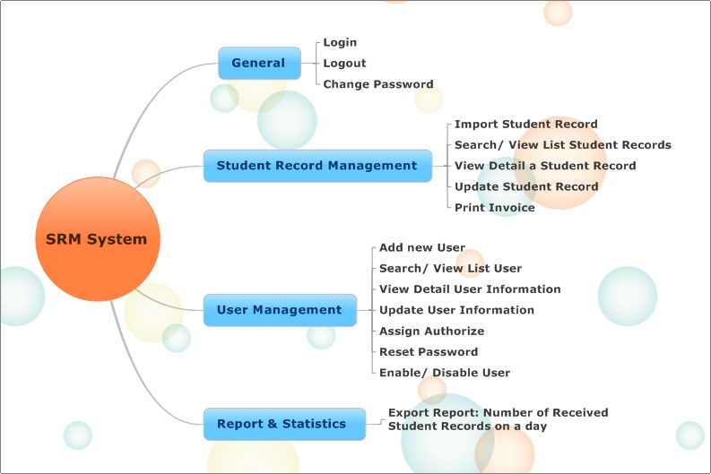

|  |  |  |
| --- | --- | --- |
| Product features | System Features | Functions |
| Easy to use | Change language with purpose |  |
| Program run fast and lightly |  |
| Easier to search |  |
| Used languages are easy to understand |  |
| Auto refresh |  |
| SRM system | General | Login |
| Logout |
| Change Password |
| **Student Record Management** | **Import Student Record** |
| **Search/ View List Student Records** |
| **View Detail a Student Record** |
| **Update Student Record** |
| **Print Invoice** |
| **User Management** | **Add new User** |
| **Search/ View List User** |
| **View Detail User Information** |
| **Update User Information** |
| **Assign Authorize** |
|  | **Reset Password** |
| **Enable/ Disable User** |
| **Report & Statistics** | **Export Report: Number of Received Student Records on a day** |

## User classes and characteristics

|  |  |  |
| --- | --- | --- |
| ID | Name | Description |
| E01 | Administrator | * To have full access to the system. * Manage all kind of user account * Import Student Record for School |
| E02 | The Faculty Monitor | * Manage user account works for their faculty * Analysis statistics and report about the number received student records of their faculty * Import Student Record for Faculty |
| E03 | The Received Student Record Officer | * Update student record of their faculty Analysis statistics and report about the number student records that they received |
| E04 | The Training Department Officer | * Import Student Record for School * Analysis statistics and report about the number received student records of school |
| E05 | The Human Resource Department Officer | * Analysis statistics and report about the number received student records of school |
| E06 | The Management Committee | * Analysis statistics and report about the number received student records of school |

## Operating Environment

SRM product is built as Window Forms Application, developed on the Java programming language; it has capable of running on most bases, operating systems through the Java Virtual Machine (Java environment).  
The system shall manage information of all students in two campuses through a database that is located at campus 1. Those computers, that have installed the software, shall operate on the common database through Local LAN.

System operates in a LAN environment (intranet). It supports two languages: English and Vietnamese.

Nowadays, department, faculties and library at Van Lang University usually have specialized software to support the work of each department and SRM product shall import data from those software to use in system.

***A* local *area* network *(LAN)***

* **Server:**
* **Client:**

## Design and implement constraints

|  |  |  |
| --- | --- | --- |
| ID | Name | Description-limit |
| 1 | **Language** | -English(Us) ( default ) |
| 2 | **Technical** |  |
| 3 | **Design interface** |  |
| 4 | **Implementation Time** |  |

## User Documentation

|  |  |  |  |
| --- | --- | --- | --- |
| ID | Support as | Description | Format standard |
| 1 | Catalog Guide | The catalog is described in detail how to use  Describe the basic features  Artwork clearly and fully | It is formatted as Window Form and it is integrated in Help menu of the SRM product |

# System Features

1. **External Interface Requirements**

Reference **External Interface Requirements** appendix was attached

1. **Other Non- Functional Requirements**

|  |  |
| --- | --- |
| **ID** | **Quality Attribute Description** |
| QA01 | **Quality attribute:** Performance  **Requirement:** Users should be provided with responsive systems from all user requests. |
| QA03 | **Quality attribute:** Availability  **Requirement:** System should provide availability with very small downtime periods. |
| QA04 | **Quality attribute:** Security  **Requirement:** System should protect against unauthorized. |
| QA05 | **Quality attribute:** Robustness  **Requirement:** System should provide the mechanism that allowsthe large number of serviced users at the same time. |
| QA07 | **Quality attribute:** Usability  **Requirement:** The website interface easy to using the online software function. |

## -- The End --